Power & Propulsion system of this UAV consists of following:

* 4 EMAX GT-2826 KV860 Brushless Motors
* 14\*7’’ Carbon Fiber propellers
* Turnigy 5000mAh 4S Li-Po Battery with 40C Discharge Rate
* 20g servos for tilting individual rotors

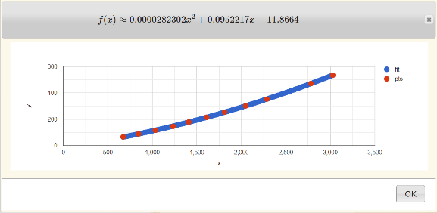These components are selected after extensive calculations for optimum performance in fly-off mission. Note: MN5008 mentioned in PDR is replaced by EMAX because it wasn’t locally available.

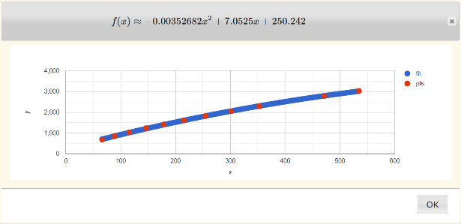 Data of all locally available motors is collected into GitHub repository. Detailed datasheet of EMAX motors isn’t available online. So, all the data from official website and thrust tests in workshops is gathered, using finite values for this motor and datasheets available for similar motors, closest continuous function was plotted against experimental values of thrust & power as shown on right.

Below are some power & thrust specifications of the motor used.

Using online calculator, thrust for single motor is written as a function of power as:

$$thrust= -0.001632532∙{power}^{2}+5.3238∙power+250 --- (i)$$

This continuous function gives precise value for power between 50-850 Watts. Lift & Drag values for whole airframe on different airspeeds were obtained from simulations (detail in aerodynamics part). Again, using finite values, estimated function was plotted for both lift & drag against airspeed.

$$lift=0.350317∙v^{2}-0.202576 ∙v ---(ii)$$

$$drag=0.0350823∙v^{2}+0.00372739∙v ---(iii) ∴v=airspeed$$

Cruise speed is calculated as:

$$lift=0.350317∙v^{2}-0.202576 ∙v= total mass of drone$$

Using this relation, ideal cruise speed with full payload i.e., 6.9kg (flight towards Spray Zone) comes out to be 14.2ms-1 and cruise speed without payload i.e., 3.9kg (flight back to landing) comes out to be 10.7ms-1.

Power consumption is calculated as:

$$drag= 0.0350823∙v^{2}+0.00372739∙v=thrust of propulsion system$$

Thrust required for full payload comes out to be 0.727237 kgf (0.181809 kgf each motor). Power consumed to require this thrust is calculated by eq. (i) and it comes out to be 84.5723W (21.143W per motor). Similarly, thrust required without payload is 0.421658 kgf and power consumption is 47.8332W.

Calculating energy consumption & time taken for ideal cruise flight of 4km from take-off to spray zone and 500m from spray zone to landing:

$$time= \frac{4000m}{14.2{ms}^{-1}}+ \frac{500m}{10.7{ms}^{-1}}=328.42s \left(Approx. 5_{2}^{1} minutes\right)$$

$$energy=84.5723W∙281.7s+47.8332W∙46.7s≈7.2383 Wh \left(<10\% of available battery\right)$$

Ideal time & energy consumption calculations for take-off, transition, spray zone & landing were done. Calculations are too complicated to be added in CDR. Results are given below:

Energy capacity of battery is 74Wh which is about 160% of total power used in flight via 4km route.